Kelsey Theatre has a new hearing loop Assisted Listening System!

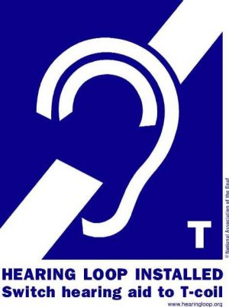
This system has amazing clarity for patrons with hearing aids and those without hearing aids. Hearing loops are assistive listening systems that exist in many public venues all over the world to assist those with hearing loss. All Broadway theatres and most synagogues and churches have one. This inductive loop system provides a magnetic, wireless signal that is picked up by hearing devices with telecoils. When hearing aid users are inside the loop (in this case the audience area) and their t-coil setting is activated, any conversation being broadcast on our audio system is sent directly to the telecoil in their hearing device. This feature not only extends the listening range of hearing devices, it also eliminates unwanted background noise, increasing listening comprehension and enjoyment.
Telecoils are in use anywhere that you see this sign

What are Telecoils?

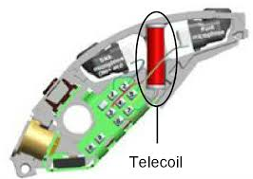
A telecoil is the bridge between your hearing aid and a public assistive listening system (ALS). If you want to hear better in public places, yes, you do want a telecoil in your hearing aid.
A telecoil is the small copper coil in most hearing aids and all cochlear implants. The t-coil serves as a wireless receiver and connects you to all assistive listening systems (loops, FM, and infrared.)
A telecoil picks up the electromagnetic signal from a sound source such as a microphone or a PA system. The signal is processed by the hearing aid or cochlear implant, then passed on to the auditory nerve as sound. The sound is customized for each listener’s hearing loss, providing exceptionally clear understanding.
How do I use it with my hearing aids?
Many people with hearing aids do not know if their hearing aid has a telecoil or how to use it. Ask your audiologist if your hearing aid has a telecoil, and make sure it is activated. If you already have one activated all you have to do is push the button on your hearing aid to access it.
Although some hearing aid manufacturers have removed telecoils to make the devices smaller, the feature is still standard in most hearing devices. If you are considering buying hearing aids soon, make sure you consider telecoils before you buy.
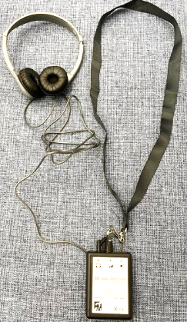

What if I don’t have hearing aids?
Many people have hearing issues but do not yet have hearing aids. The Kelsey Theatre has Listening Receivers, which you can borrow during the show. You either may use the provided headset, or if you prefer you may use your own plug in Earbuds, as it is a standard size jack. If you would like to borrow one, please ask the House Manager or at the Box Office, and we request a drivers’ license or other card to hold as a reminder to return it after the show.
Funding for this Assisted Listening System has been made possible in part by the Mercer County Cultural and Heritage Commission through funding from the Mercer County Board of Chosen Commissioners and the New Jersey State Council on the Arts/Department of State, a partner agency of the National Endowment for the Arts.

